Numerical Simulation of Microwave Induced Stress in Rocks

# Table of Content

# Introduction

Mechanical method of tunneling requires large amount of energy.

Thorough tremendous development in comminution, the lives of the cutter blades have been greatly extended. However, the excessive high wear of the blade in abrasive or hard rock still presents huge challenge to this method of rock breaking.

Microwave offers great improvements to the process as a method of preprocessing the rock. The preprocessing heating and cooling of the rock greatly reduce the strength required for the boring process.

The process of heating and cooling rapidly introduce great amount of thermal stress in the body. Depending on the Electromagnetic, thermal and mechanical property of the body, enough energy delivered in a short timeframe can exceed the ultimate tensile strength of the rock and cause the inter crystal fracture and intra crystal fractures to form. These fractures reduce the structure integrity of the rock and allow boring blades to deliver their energy more efficiently.

# Literature Review

# Methodology

The entire simulation is built in a step by step manner to give a holistic view of the process.

## Geometric construction

Several different simple geometric shape are designed and investigated using MEEP. The configurations include different particle sizes, shapes and different distant between the particles.

The simple geometries gives us an understanding of the nature of EM wave propagation as an intensity profile can be generated from the resulting EM wave profile.

Complex geometry that are more closely resemble the real-life situation

The geometry is generated using Python **Voronoi** Algorithm.

**Voronoi** algorithm generate randomized geometry based on the randomly generated seeds and the distance of each section of geometry is from the seeds.

The geometry is then transferred to Abaqus using **Convex Hull** algorithm.

In the figure shown. The solid parts are the microwave-absorbing particles and the transparent parts are the microwave-transparent matrix.

Ratio of the particles and density of the particles is customized.

The mechanical property of the micro-structure is also randomized using Weibull distribution.

## Electromagnetic simulation

EM field is generated and propagated in the software MEEP.

The MEEP is an open source Finite Difference Time Domain (FDTD) software.

We constructed different geometry and materials for EM wave propagation test. A procedure is store the randomly generated geometry in a database and read it in MEEP for simulation.

Different frequency of EM wave is also specified to test.

The result of MEEP simulation is analyzed in MATLAB to assert the correctness.

A Root Mean Square (RMS) value matrix is generated to discover the absorption of different parts of the model.

## Thermal simulation

## Structure simulation

## Fracture simulation

# Future improvements

## Methodology improvements

## Simulation chain extension

# Results

Distribution of the particles greatly affects penetration and power distribution of the EM field.

The results show that the less dense particle, the greater the penetration. The particles also focus the beam and increase the strength of the field beyond them.

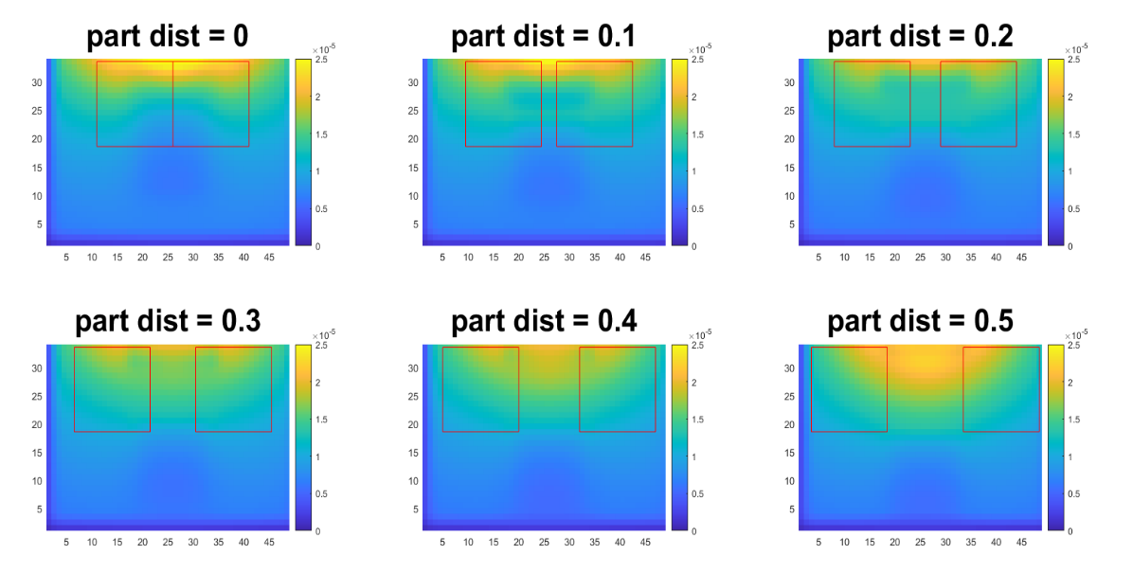

Figure . RMS energy profile of Different particle distance

The frequency of EM wave has a dramatic effect on the efficiency of the wave penetration and heating in the rocks.

The results show that the lower the wavelength, the deeper the penetration.

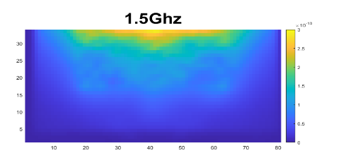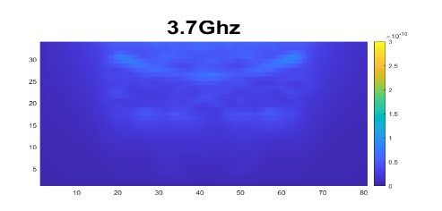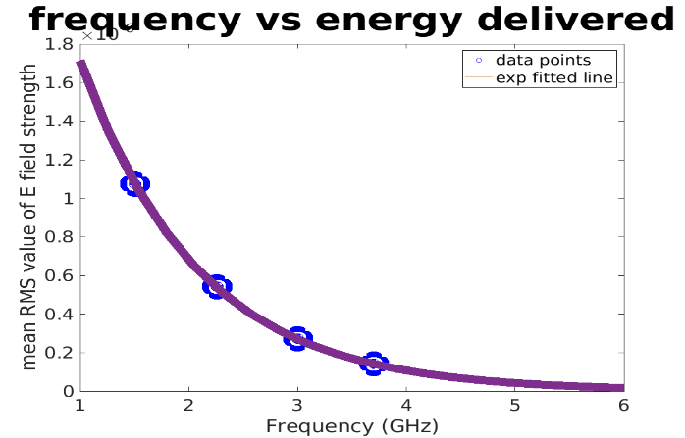

Figure . RMS energy profile of E field (left) and fitted line of frequency vs Energy delivered

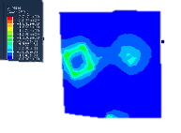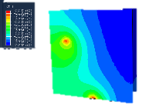

The thermal and stress are coupled in simulation in Abaqus.

The results show that the temperature gradient is the major cause of stress.

Figure . Co-simulation of thermal and stress on rock sample stress field (left) and temperature field (right)

# Conclusion

In this paper, a novel approach to preprocessing the rock using microwave before the mechanical comminution is presented.